UnitedTune Web Application

Business Requirements Document

Project: UnitedTune Web Application

Author(s): John Brilhart, Hetali Chavda, Revati Deshmukh, Ge Ou, Jay Patel, Suraj Suwal, Soyeon Ju, Yashwanth Varre

Table of Contents

**Project Overview** **3**

**Document Information** **3**

2.1 Audience 3

**Business Opportunity** **4**

3.1 Project Overview and Background 4

3.2 Current State Analysis 4

3.3 Future State Objectives 4

3.4 Business Domain Model and Stakeholders 4

**Business Requirements** **5**

4.1 Details of Business Requirements 5

**Non-Functional Requirements** **7**

**External Data Feeds (reference Context Diagram)** **8**

**Business Risks** **8**

# **Project Overview**

This document describes the business/user requirements for the UnitedTune applications that will provide the basis for the following project activities:

* Introducing business/user requirements
* Creating test plans and test specifications
* Identifying stakeholders
* Devising solutions to project tasks
* Produce an application that will enable customers to connect musicians selling their services directly from the website
* Determining when the project is complete
* Assessing the degree to which the project succeeded

# **Document Information**

## 2.1 Audience

|  |  |  |
| --- | --- | --- |
| Name | Business Group | Role |
| Social media / Event Management Agencies | Marketing / Advertisement Group | Suppliers |
| IT company / Software engineers | Tech Support/ Account Management | Partner/ Suppliers |
| Payment Merchants | Finance Group | Partner |
| Customers | Customer Support Group | Web Application Users |

# **Business Opportunity**

## 3.1 Project Overview and Background

UnitedTune is an online rental web application aimed at taking band/musician rental services to customers' fingertips. The web application acts as an open platform where customers and musicians can come together, musicians can advertise their services, and customers can select services based on their interests. The web application does not offer any other event management services; it only provides band/musician rental services to make their event more memorable. Overall, UnitedTune is a platform that will motivate musicians to offer their services to customers. Customers will be able to see these services and their availability and make reservations from the web application with just a few clicks.

## 3.2 Current State Analysis

We acknowledge that many events have had to be cancelled or rescheduled due to the COVID-19 pandemic this year. Before the Pandemic, customers and musicians, looking to hire or share their services would rely on word of mouth or other efforts to find new budding musicians and new mediums of expression. UnitedTune provides a platform for musicians to advertise their services. It gives an opportunity for artists to show their skills and motivate them to create good music by offering them extra earnings. On the other side, it serves as a great research source for the customers to hire musicians of their interest in life events like weddings, birthdays, graduation, etc. Usually, it is very hard to find a good resource on such artists and most people have no idea on where to start from if they want to hire musicians. UnitedTune solves that issue by offering plenty of information about services, types of music, areas of operation, and costs all at one place. Customers will be able to make a choice suitable for their event by listening to the compositions, reading the reviews of the artists they would like to hire and also by comparing prices. The front-end part will be built in HTML and the back-end part will be built in JAVA. Our web application will utilize a social data set delivered by SQL. The arranging interaction for the application is in progress, and the advancement of the project will traverse two semesters at Pace University.

## 3.3 Future State Objectives

In today’s pandemic time almost all businesses are moving on-site to online. The objective is to create a web application that will act as an open platform where customers and musicians can come together, musicians can advertise their services, and customers can select services based on their interests. Having an online platform for such things will provide more convenience and ease. Also, musicians don't need to spend their resources (time + money) on marketing and there will be no dependency on any middle man. A customer can reach out to a musician/band directly.

## 3.4 Business Domain Model and Stakeholders

|  |
| --- |
| Stakeholders |
| Marketing / Advertisement Group |
| Finance Group |
| Customer Support Group |
| Tech Support/ Account Management |
| Social Media Partner |
| Event Management agencies |
| Customers |
| Subscribed Musicians |

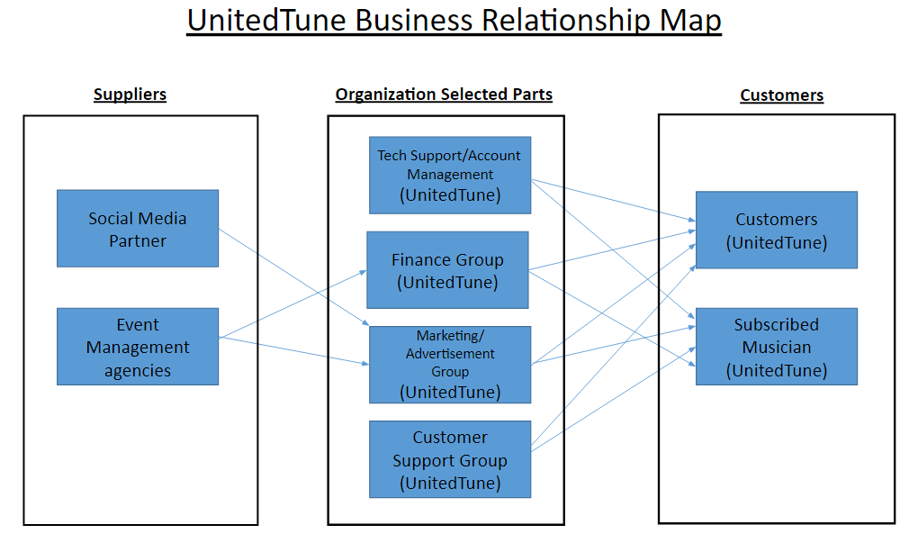

# **Business Requirements**

The primary purpose of UnitedTune is to provide a portal for musicians to sell their services to customers. Services could include musical appearances, recordings, lessons and concerts. Musicians using the platform would be charged a commission in exchange for using the platform. The following requirements are needed to fulfill this purpose for the UnitedTune web application.

## 4.1 Details of Business Requirements

**Marketing/ Advertisement Group**

4.1.1.1 Ability to generate ads on web application

4.1.1.2 Ability to restrict the content of an advertisement

4.1.1.3 Ability to filter ads based on user preference

4.1.1.4 Ability to promote the sponsored ads

4.1.1.5 Ability to maintain ads up to date

4.1.1.6 Ability to view website analytics

**Account Management/Technical Support**

1. Ability to troubleshoot, identify, and find solutions related to technical issues or platform problems for end-users (Customers and Musicians)
2. Ability to provide exceptional customer service while responding to phone, e-mail, and online request for technical support
3. Ability to track and monitor all technical support cases to ensure timely resolution and follow-up
4. Ability to communicate technical issues and solutions to development, QA, sales, and customer support teams as well as to the end-user base
5. Ability to perform end-users account management activities
6. Ability to escalate critical end-user situations to the appropriate level of management and development expertise
7. Ability to update website software and optimize speed.
8. Ability to fix errors and broken links
9. Ability to back up files
10. Ability to maintain and improve the website
11. Ability to set and modify the notification settings

**Finance Management**

4.1.3.1 Ability to process all kind of payments and payout commissions to musicians for the service

4.1.3.2 Ability to generate invoices and payrolls

4.1.3.3 Ability to verify the form of payments

4.1.3.4 Ability to update financial documents to comply with laws and regulations

4.1.3.5 Ability to provide quotes on services

4.1.3.6 Ability to generate financial reports

4.1.3.7 Ability to settle any payment disputes

**Customer Support Service**

4.1.4.1 Ability to create and resolve customer service complaints for customers and musicians

4.1.4.2 Ability to access information of both customer and musicians accounts

4.1.4.3 Ability to refund customer payment in case of fraud

4.1.4.4 Ability to escalate customer problems to appropriate levels

4.1.4.5 Ability to freeze and unfreeze accounts in cases of identity theft

4.1.4.6 Ability to track and monitor multiple customer support tickets

4.1.4.7 Ability to communicate with end user

**Customers requirements**

4.1.5.1 Ability to create/delete/modify an account or information

4.1.5.2 Ability to restore the password/user ID details

4.1.5.3 Ability to sign in to (sign out from) already created account

4.1.5.4 Ability to select/pause the subscription plan

4.1.5.5 Ability to read the service details/agreement

4.1.5.6 Ability to add/remove services chosen to/from the subscribed box

4.1.5.7 Ability to cancel the service before a specified date

4.1.5.8 Ability to create profile of liked/disliked services/musicians

4.1.5.9 Ability to view/redeem offer coupons

4.1.5.10 Ability to view the service booking history

4.1.5.11 Ability to search for nearby services according to address

4.1.5.12 Ability to provide the additional requirements instructions

4.1.5.13 Ability to enter/modify the payment information

4.1.5.14 Ability to view/ submit customer support queries

4.1.5.15 Ability to read the resolution of the opened ticket with customer support team

4.1.5.16 Ability to share the satisfaction with the services on social media

4.1.5.17 Ability to make artist/service or product favorite

4.1.5.18 Ability to view the list of favorite/featured artists

4.1.5.19 Ability to leave the reviews

4.1.5.20 Ability to rate the services

**Subscribed Musicians requirements**

4.1.6.1 Ability to create an account

4.1.6.2 Ability to delete the account

4.1.6.3 Ability to modify the account information

4.1.6.4 Ability to restore the password/user ID details

4.1.6.5 Ability to sign in to (sign out from) already created account

4.1.6.6 Ability to add the service information

4.1.6.7 Ability to add/remove customer’s profile to/from the subscribed box

4.1.6.8 Ability to cancel the booking

4.1.6.9 Ability to rate liked/disliked customer

4.1.6.10 Ability to skip a future booking

4.1.6.11 Ability to view the booking history

4.1.6.12 Ability to enter/modify the contact information

4.1.6.13 Ability to provide the additional information (i.e Offers)

4.1.6.14 Ability to enter/modify the payment information

4.1.6.15 Ability to get/read the customer reviews

4.1.6.16 Ability to share the specific service on social media

4.1.6.17 Ability to make service attractive

# **Non-Functional Requirements**

|  |  |
| --- | --- |
| **Category** | **Requirements** |
| **Usability** | The application GUI will provide a user-friendly intuitive design with all the features clearly displayed for the user |
| **Usability** | The application navigation will be self-explanatory by clear and concise descriptions and names of each section, as well as features will be clearly evident by proper location and naming |
| **Usability** | Accessibility will be supported for the disabled users as well |
| **Performance** | The application will be supported on different operating systems and browsers, and should not impact the user’s system capabilities |
| **Performance** | The application will be available for 24/7 without any interruptions, and regular maintenances will be scheduled to support the application |
| **Performance** | The application will support the concurrency where the users will be able to simultaneously browse the app, login & subscribe, make payments, book the musician |
| **Performance** | The application will have short response time to all requests and all the features should be available and not impacted by latency |
| **Security** | The application will be using the automated daily & weekly audits to detect the vulnerabilities. |
| **Security** | The application will use HTTPS protocols for any data exchanges, enforced TLS for all the email communications, and other encryptions that will be maintained on the server |
| **Database** | The application will be using the MySQL database |
| **External System** | The application will be able to interface with the external data feeds from and to payment merchants, ad agencies, social media websites, etc… |

# **External Data Feeds (reference Context Diagram)**

* Payment Methods

Payment will be processed by finance management, the payment information will sent to the United Tune web Application.

* Displaying Ads

Advertisement from our social media partners will be fed into our application, increasing revenue and exposure.

* Organizing of events

Event management agencies will feed concert information and ticket availability so that artist can advertise their concerts

* Providing Service agreements,trademarks and copyrights

Law firms will provide the correct service agreements, trademarks and copyrights so that the website can host the musicians music and services.

# **Business Risks**

There are not many platforms or websites that provide the musical services for day to day events. That gives an upper hand in gaining business, however the toughest part is to make people aware of our website and services we provide. This can be done with plenty of advertisements and promotions which are always great business strategies. Another challenge is to increase the number of subscriptions of musicians such that the service can be utilized in various regions. Ability to provide services in a wide area means more customers and more customers means obviously more business and income. Subscribing quality musicians is very hard. Even though our website is open to any musicians, renowned musicians and quality music are automatic advertisements. Many of these risks will be offset by promotion of the platform to musicians on social media platforms. Another risk is providing services during a pandemic. This can be offset by promoting services from the musicians that can be provided remotely such as recordings and lessons.